

Forest School Handbook

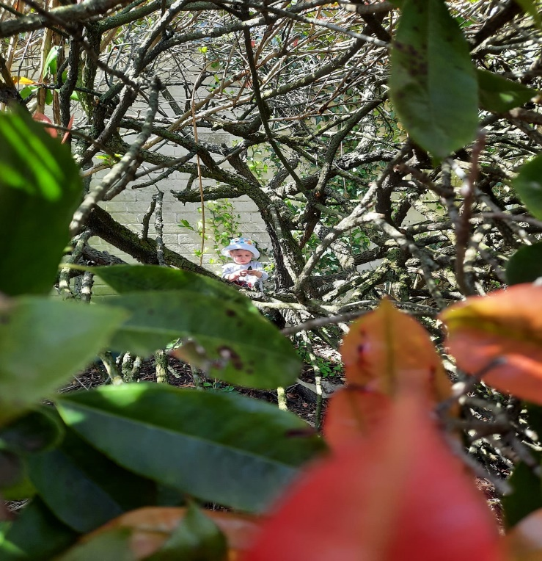

*‘The Best Classroom and the Richest Classroom*

*Is Roofed Only by The Sky’*

*(Margaret MC Millan)*

*To be reviewed September 2024*

**Contents page:**

1. Forest School Ethos
2. What to expect
3. Suggested activities.
4. Key features of Forest School
5. Forest School rules
6. Forest School site
7. Environmental Impact
8. Forest School consent form
9. Daily Procedures

**Policies and Procedures:**

* Safeguarding Children and Confidentiality
* Equal Opportunities and Inclusion
* Missing Child
* Health and Safety
* Manual Handling
* Weather
* Accident and First Aid in Forest School
* Reporting near misses
* Behaviour
* Using and Storing Tools
* Bow Saw rules
* Lopper rules
* Knife rules
* Billhook rules
* Kelly kettles
* Fires
* Food hygiene and campfire cooking
* Extinguishing the fire

Forest School Ethos

What is Forest School?

Forest School promotes child-initiated learning at its best. There is much evidence to say, learning that takes place outdoors and whilst they are active, is much more powerful and memorable as all the senses are involved

Forest School arrived in the UK in 1993 although Its roots reach back to the open-air culture, friluftsliv, or free air life, seen as a way of life in Scandinavia where it originally began.

It has a developmental ethos which is shared by thousands of trained practitioners who are constantly developing their own learning skills to support new and imaginative learners.

The process helps learners develop socially, emotionally, spiritually, physically and intellectually and facilitates more than knowledge-gathering. Forest School encourages learners to try new activities and take risks in a non-judgemental, nurturing environment. The children learn to become independent in their physical skills and mental thought processes, learning to trust their own ideas, believe in their capabilities and recognise their own needs. They are free to explore and discover whilst learning how to manage appropriate risk, which is vital in their decision-making. Adults are there to guide and support the children when needed, look out for any dangers and of course celebrate the learning which is taking place.

Central to all of this is the environment. The children are able to experience the seasons, the wonders of nature, life and death which enables them to build a strong, positive relationship with their natural world.

A Forest School encourages children to:

* Develop personal and social skills
* Work through practical problems and challenges
* Use tools to create, build or manage
* Discover how they learn best
* Pursue knowledge that interests them
* Learn how to manage failures
* Build confidence in decision making and evaluating risk
* Develop practical skills
* Understand the benefits of a balanced and healthy lifestyle
* Explore connections between humans, wildlife and the earth
* Regularly experience achievement and success
* Reflect on learning and experiences
* Develop their language and communication skills
* Improve physical motor skills
* Become more motivated
* Improve their concentration skills
* Improve their communication
* Explore the world through all the senses available to them.

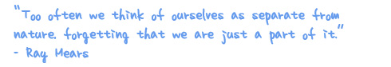

The children will be using a variety of equipment during their sessions. When using the tools children will be provided with the correct personal protective equipment (PPE) and will be asked to use them when using the tool. Before using a tool the children will be given a tool talk and advised on which PPE to wear. Children will not be allowed to use the tools without the correct PPE.

Suggested Activities for Forest School?

|  |  |
| --- | --- |
| Shelter building  Using tools  Fire lighting  Forest art  Using a Ghillie Kettle  Planting and harvesting  Carving and whittling  Sculpture with natural materials  Looking after wildlife  Building bird boxes  Looking closely at wildlife | Group games  Cooking on an open fire  Pond dipping  Learning knots  Physical challenges  Building bug homes  Rope and string work  Bug hunting  Team games  Telling and listening to stories  Free play |

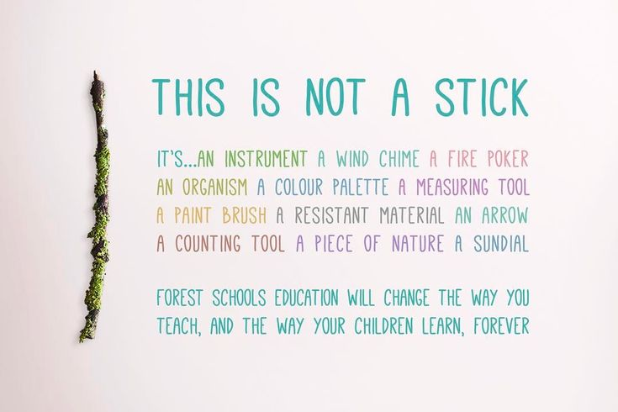

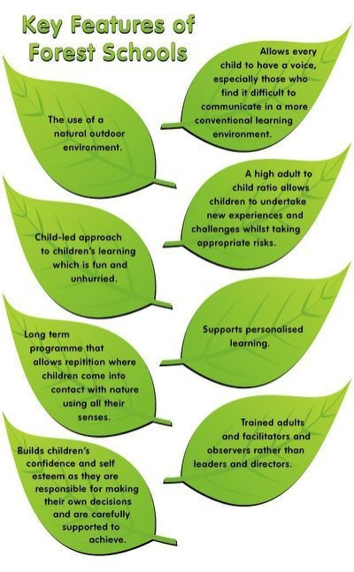

Forest School Rules:

* We use our eyes and ears.
* We only enter camp when we are invited.
* We kneel when cooking around the fire, one knee up and one knee down.
* We leave sticks etc out of the camp area.
* We always walk.
* We always think about the risks before choosing whether to do something.
* We keep our hands away from our mouths.
* We can always see camp unless we’re with an adult.
* We treat others and what they have made with respect.
* We have fun!

Forest School Site:

Our Forest School site is in the grounds of Broomley First school although sometimes, we may leave our site to go on nature walks in the local area. These walks will be planned in advance of the session.

On occasion we may visit the Glebe Woodland site that is used by the school but of course permission will be sought by parents before a visit.

For the remainder of this term (summer 2021) sessions will take place on a Wednesday.

Our ratios for Forest School sessions remain at 1:6 on site, however, if we do visit the Glebe Woodlands the ratio will be considerably higher.

Forest Schools must be led by a Level 3 qualified Forest School leader. Tina Gray (Manager) and Vanessa Hucklesby (Chairperson) are both qualified to this level.

Consent forms are required for each child before they can attend Forest School sessions.

Our insurance with Morton Michel covers us for Forest School activities.

Forest School takes place once a week and in most weather conditions. High wind or excessive rain will result in activities being cancelled for health and safety reasons.

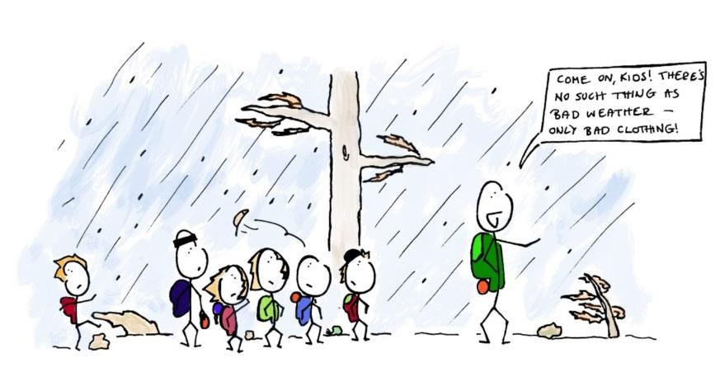

Clothing is obviously weather dependent, therefore please ensure your child is dressed appropriately. At all times of they year, the children should have their arms and legs covered, to protect them from scratches & ticks. (trousers and long-sleeved tops). Children should also wear wellies or walking boots.

In winter or wet weather, children are required to wear waterproof clothing (these will also be used during any water play.) They will also need hats and gloves and it is advised to layer clothing for warmth.

In the summer, they will need a sunhat and to have had sun cream/protection applied prior to the session.

Environmental Impact

It is important that children learn to look after our woodlands and outdoor spaces. They need to learn how to share the woodland with animals and plants and know how to look after them. Forest School will encourage them to take responsibility for this and develop a respect for the natural world. Forest School sessions should not have any negative impact on the Forest School site and there should be no evidence of our visit after we have left.



**Broomley Pre-school**

**Forest School Consent Form**

**I give permission for my child**

**Name:**

**to take part in all Forest School activities.**

**Signed:**

**Relationship to child:**

**Date:**

Please return to Broomley pre-school

**DAILY PROCEDURES**

To ensure the safety of children and adults attending Forest School sessions, there are certain checks that need to be made before, during and at the end of each session. It is the Forest School Leader’s responsibility to ensure that all checks have been completed. This daily health and safety checklist provides a reminder of all daily procedures.

This must be used each day. Pre-visit checks

• Run through the site risk assessment and amend/update as necessary. Remove all visible litter and faeces.

• Remove obvious trip hazards and mark off areas as out-of-bounds where appropriate.

• Cut any overhanging vegetation from paths and boardwalk.

• Ensure risk assessments are completed for all activities.

• Erect shelter(s) if using

• Set up Forest School circle.

• Set up hand washing station.

• Check that the forest school rucksack contains all necessary items including all emergency procedure information, a stocked and in date first aid kit, fire blanket and dated fresh water.

• Check you have all the materials and resources needed for the activities you have planned.

• Check that all tools you are planning to use are in good working order.

• Check that your phone is in working order and is fully charged.

• Take register and head count.

• Remind children about physical boundaries (use visual cues when needed) and that they must stay within these. In the first sessions, and at the beginning of each session play a game to reinforce this. • Remind children how they should behave and how to stay safe on site

• Explain the need for, and principles of, fire safety. Throughout the session

• Be vigilant.

• Remind children of how to stay safe by highlighting potential hazards, reminding them of the boundaries and asking that they make an adult aware of any possible hazards that they spot.

• Carry out regular head counts.

• Carry out a final head count and escort the group back to the school.

• Count and pack up all equipment.

• Count and pack up all resources.

• Clear fire area and make safe. Remove ash and cover over the site of fire.

• Evaluate the session.

**WHAT TO WEAR WHEN TAKING PART IN FOREST SCHOOL**

**Winter**

• Waterproof coat

• Waterproof trousers

• Wellington boots

• Warm hat, scarf and gloves

• Warm trousers

• Long-sleeved jumper or fleece

• Long-sleeved top

• Vest or t-shirt

• Thick socks - thermal if possible or two pairs of thinner ones

• Waterproof coat and waterproof trousers in bag

• Walking boots or wellington boots - sandals are not suitable

• Sun hat

• Sunscreen

• Long-sleeved top or light shirt - to protect shoulders and arms

• Light trousers - shorts/skirts are not suitable

**Policies and Procedures**

**Safeguarding Children and Confidentiality**

At Broomley pre-school we have a comprehensive set of Safeguarding policies which will also apply to all Forest School sessions. Please refer to these for information and advice on safeguarding. A summary of these policies is included below:

* Every child has the right to be safe from harm and danger. It is everyone’s responsibility to ensure every child is free from fear and able to learn and develop in safe, secure environments.
* We are committed to ensuring that every child is safe in our setting and we take this responsibility very seriously.
* All staff attend regular safeguarding training
* All staff receive an enhanced Disclosure and Barring Service check
* Staff will respond promptly and appropriately to all incidents or concerns of abuse that may occur and work with statutory agencies as required.
* Our Safeguarding Lead Practitioner is Sophie Lowes and our Deputy Safeguarding Lead Practitioner is Tina Gray. Any concerns must be discussed with one of them.
* All suspicions and investigations are kept confidential and shared only with those who need to know.
* Children will be accompanied to the school toilets by a qualified member of staff. Volunteers are not permitted to do this.

**Equal Opportunities and Inclusion**

Broomley Pre School will endeavour to make our service fully inclusive in meeting the needs of all children who attend. We recognise that children and their families come from diverse backgrounds. All families have needs and values that arise from their social and economic, ethnic and cultural or religious backgrounds. We will make every effort to ensure that our activities are accessible to all children and adults by making appropriate changes to the environment, resources and activities. However, there may occasionally be times when we are unable to do this. Children are respected as individuals and given opportunities to participate and succeed regardless of their ability or style of learning. Forest School activities will encourage children to develop positive attitudes about themselves as well as to people who are different from themselves.

**Missing Child**

Children’s safety is maintained as the highest priority at all times both on and off premises. Every attempt is made through following Pre School procedures, to ensure the security of children is maintained at all times. In the unlikely event of a child going missing, our missing child procedure is followed.

* As soon as it is noticed that a child is missing, staff will gather the remaining children together for a headcount to check that no other children are missing.
* An adult will shout, “1, 2, 3 Come back to Me!” while other available adults search the immediate vicinity.
* If the child is not found within 5 minutes, the emergency services will be contacted and the child’s parents will be informed.
* Adults will stay with the remaining children to keep them safe and calm while the search takes place.

**Health and Safety**

This is in addition to the full Health and Safety Policy which can be found in Broomley pre-school.

All staff and any adult helpers will be asked to read this Handbook and relevant risk assessments before participating in Forest School sessions. The Risk Assessment will be carried out by the Leader, signed and dated.

The Forest School Leader is the person responsible for Health and Safety during

Forest School sessions. However, all adults involved in the Forest School session are required to take all reasonable steps to ensure that children are safe

Essential equipment will be taken to the site by a member of staff and will include:

* A copy of this Handbook
* First Aid kit
* Burns kit
* List of children with allergies and medication
* Emergency contact list
* Risk assessments
* Accident forms
* Spare clothes
* Register
* Anti-bacterial wipes/sanitizer

The Forest School Leader will carry a mobile phone and there will be a

supply of clean water, drinks and snacks.

**Manual Handling**

• Correct handling techniques must be followed to minimise the risks of injury. A variety of injuries may result from poor manual handling and staff must all be aware and adhere to the pre-schools Manual Lifting Policy. (Found in the classroom)

• The Forest School Leader is responsible for modelling safe manual handling to the children and assessing their age and ability whether it is safe and appropriate for them to move loads such as logs or rocks, due to the weight, size and shape, taking into consideration factors such as weather conditions.

**Weather**

Exposure to the elements is part of the magic of nature and therefor an integral part

of the Forest School experience. Therefore, Forest School sessions will go ahead in all weather conditions with only a few exceptions.

* Strong winds that make our forest area hazardous due to falling debris.
* Very wet freezing conditions where hypothermia could be a real possibility.
* Thunder and lightning.
* If snow is falling heavily, freeing and causing ground to become slippy or icy.
* If it is too hot and the children are at risk of sun exhaustion.

**Accident and First Aid in Forest School**

The Forest School Leader must hold an up to date outdoor first aid qualification alongside an up to date paediatric first aid certificate.

All other practitioners who take part with Forest School activities alongside the Forest School Leader will hold an up to date first aid certificate.

The person responsible for reporting accidents, incidents or near misses is the paediatric first aid trained member of staff who witnesses the accident.

They must record it on a Forest School Accident form and report it to the Forest School Leader. It should be done as soon as the accident is dealt with, while the details are still clearly remembered.

The Forest School Leader will check the accident book weekly for any possible patterns to be identified e.g., an accident occurring in the same place.

This will be recorded in a separate file. Any patterns will be investigated and addressed, if necessary, by the Forest School Leader.

The Forest School Leader has access to a First Aid kit and a Burns Kit will be located in the Forest School environment at all times.

The pre-school First Aid policy will be followed at all times by all practitioners.

**Reporting near misses**

Due to the nature of Forest School being led in an environment where there can be unknown factors that could cause serious injuries there is a need not only to report accidents but also incidents that are “Near misses” where serious injury or death could have been the result. These occurrences are likely to be few due to the precautions that have already been put in place to prevent serious injury or death, but if an incident like this does occur these need to be documented in the accident book and existing policies, procedures and risk/benefit analysis need to be reviewed.

**Behaviour**

It is essential that children follow the Forest School rules and adhere to the directions given to ensure safety for all.

If it occurs that these rules are not being adhered to and behaviour in individuals begins to escalate, the behaviour policy should be followed.

* Children will be taken back to the pre-school if necessary.
* Debrief child after calm down period.
* Log incident.
* Inform parents/guardian.

**Using and Storing Tools**

**General rules**

* Tools will be kept maintained and in good order
* Tools will be inspected before each session
* Children and adults will not use tools until they have been shown how to use them
* Tools will be kept in the toolbox or designated area when not in use
* Tools will be removed from the toolbox only by the Forest School Leader
* We never run with tools
* Tools will be counted at the beginning and end of each session
* Permission to use tools can only be given by the Forest School Leader
* Permission to use tools may be withdrawn at the Forest School Leader’s discretion if the rules are not followed
* The working area should have sufficient space (at least two arms and a tool away from anyone else) and be clear of trip hazards

**Bow Saw rules**

* Bow saws must have a blade guard on when not in use
* Supervision ratios are 1:2
* Bow saws are used to cut anything larger than a 2 pence piece
* A glove must be worn on the helping hand (children and adult sizes are available)
* Wood being sawn must be supported on a safe cutting bench The crossed hands method must be used to start sawing

**Lopper rules**

* Supervision ratios are 1:2
* Loppers are used to cut anything smaller than a 2 pence piece
* Loppers are used with bare hands

**Knife rules**

* Knives must have a sheath on when not in use
* Supervision ratios are 1:1
* Knives are always used on the outside of the body and away from the body
* A glove must be worn on the helping hand (children and adult sizes are available)

**Billhook rules**

* Billhooks must have a sheath on when not in use
* Supervision ratios are 1:2
* Billhooks are used to split wood
* Billhooks are used with bare hands

**Kelly kettles**

* The Kelly kettle must be placed on flat, clear ground
* The Kelly kettle will be removed from the fire pan by the Forest School Leader who will wear fire gauntlets.
* The Kelly kettle must never be heated with the cork in.

**Fires**

* The fire will be contained within a square of logs
* Seating logs will be placed in a circle a safe distance away from the fire
* The seating circle will have a clear entrance and exit
* Walking within the seating circle is not permitted
* The ‘respect position’ should be used when kneeling by the fire
* During all campfire activities the Forest School Leader will ensure that there is a bucket of water next to the fire in case of emergency. The bucket will have fresh clean water, be covered with a clean cloth and have a plastic cup inside.
* Water will be available to put the fire out
* A fire glove will be available nearby
* The fire will be lit with a Swiss fire steel
* The fire will never be left unattended
* A burns kit is available

**Food hygiene and campfire cooking**

• All participants on activities will be encouraged to wash their hands with water

and soap, or cleaned with hand gel, before preparing, cooking, or eating food.

• Chopping and preparing food must be on a clean surface

• All food waste must be disposed of to avoid rodents.

• Food that must be kept refrigerated or frozen, or pre-cooked food must be kept

In a plastic tub with a lid and kept in the refrigerator until the session begins.

**Extinguishing the fire**

* All fires must be extinguished at the end of a session
* Whenever possible, all fuels should be burnt off to ash
* At the end of the session, the fire must be doused with water and stirred until cool
* The ash should be scattered around the woodland to decompose
* There should be no trace of the fire left behind